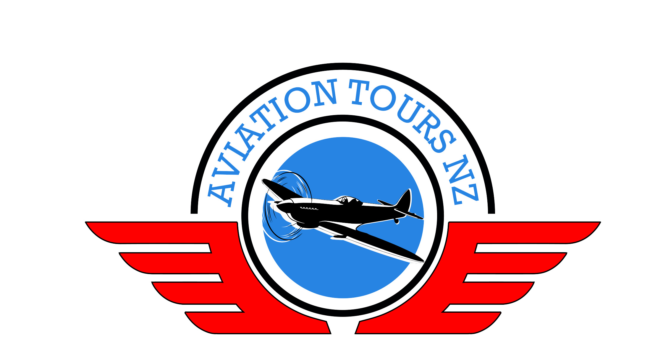
Aviation Tours NZ

Passenger 2 Full name as per passport Mr/Mrs/Ms |  | Address
Phone |  | Address
Phone (Mobile) |  | Email
Date of Birth | Size for Tour T-Shirt | Preferred name for badge
Emergency contact details – Name, Phone numbers, Relationship
Booking Form
Tour Name – | Departure Date –

Passenger 1 Full name as per passport Mr/Mrs/Ms |  | Address
Phone |  | Address
Phone (Mobile) |  | Email
Date of Birth | Size for Tour T-Shirt | Preferred name for badge
Emergency contact details – Name, Phone number, Relationship

Frequent Flyer Membership No(s) P1. P2.
Preferred Room Configuration Double / Twin / Single / Willing to Share Twin
Past guests – please advise if you do not need a Badge/T-Shirt/Backpack.
Would you like to know about room upgrades available? Superior / Suite / Sea View / 4 Poster etc
Do you have any special dietary requirements or allergies?
Will you need any pre or post tour accommodation, domestic flights or airport shuttles?
Would you like a quote for Business/Premium Economy flights or change of return date?
Please e-mail to aviationtoursnz.com or post to Aviation Tours NZ, 12 Furl Close, Pyes Pa, Tauranga 3112, NZ

